**DIVID MANUAL**

**The instruments can be charged even when the instrument is switched off with the USB connected to any available port. Once all the tools are charged, they hold their charge for at least a few days. The cables for AGMD and VHF/ARGOS are interchangeable.**

**For all cables: the cable must be inserted into the plug first in order to be able to see which end of the cable has the lights. As I insert the cables, the lights must always face the front of the DIVID (camera).**

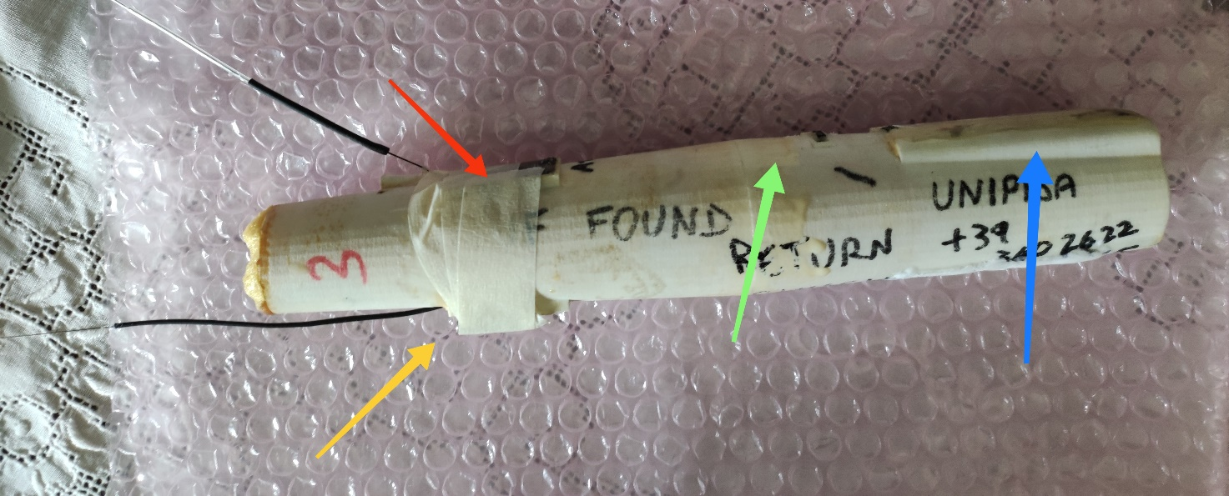

**BUOY**

**CAMERA**

**AGMD**

**VHF**

**ARGOS**

**FRONT SIDE**

**BACK SIDE**

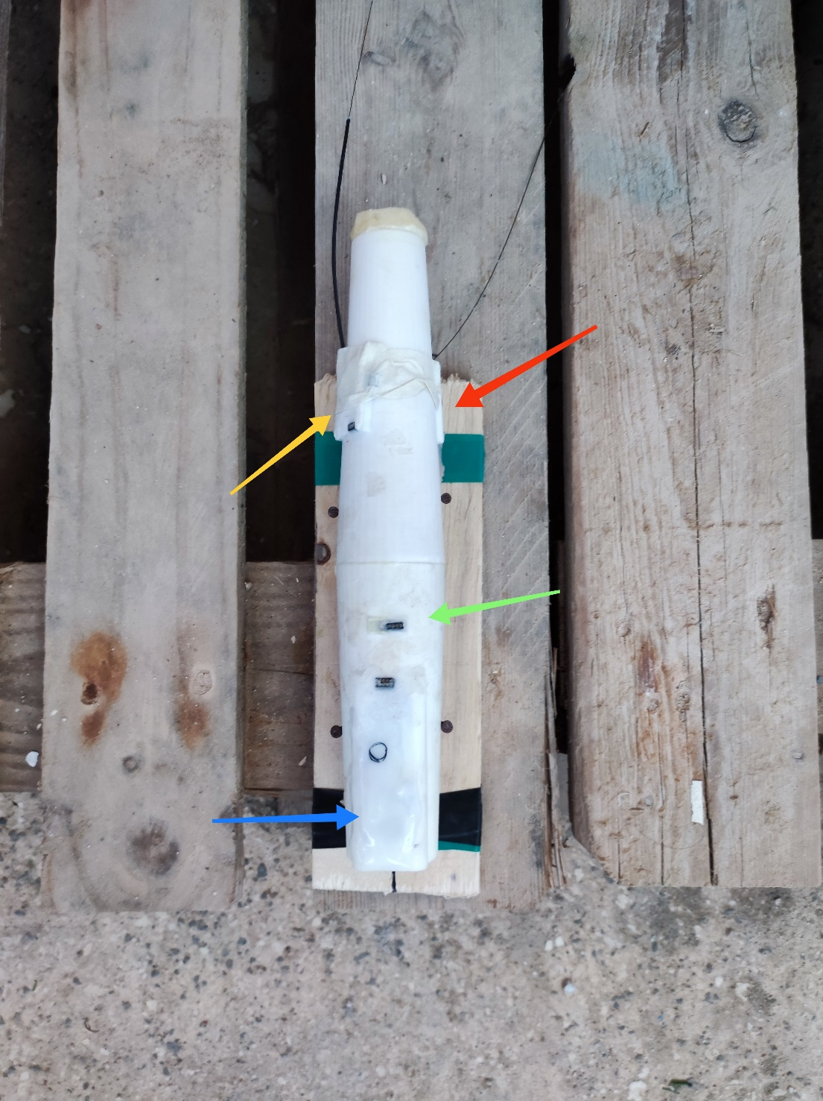

**BUOY**

**CAMERA**

**AGMD**

**VHF**

**ARGOS**

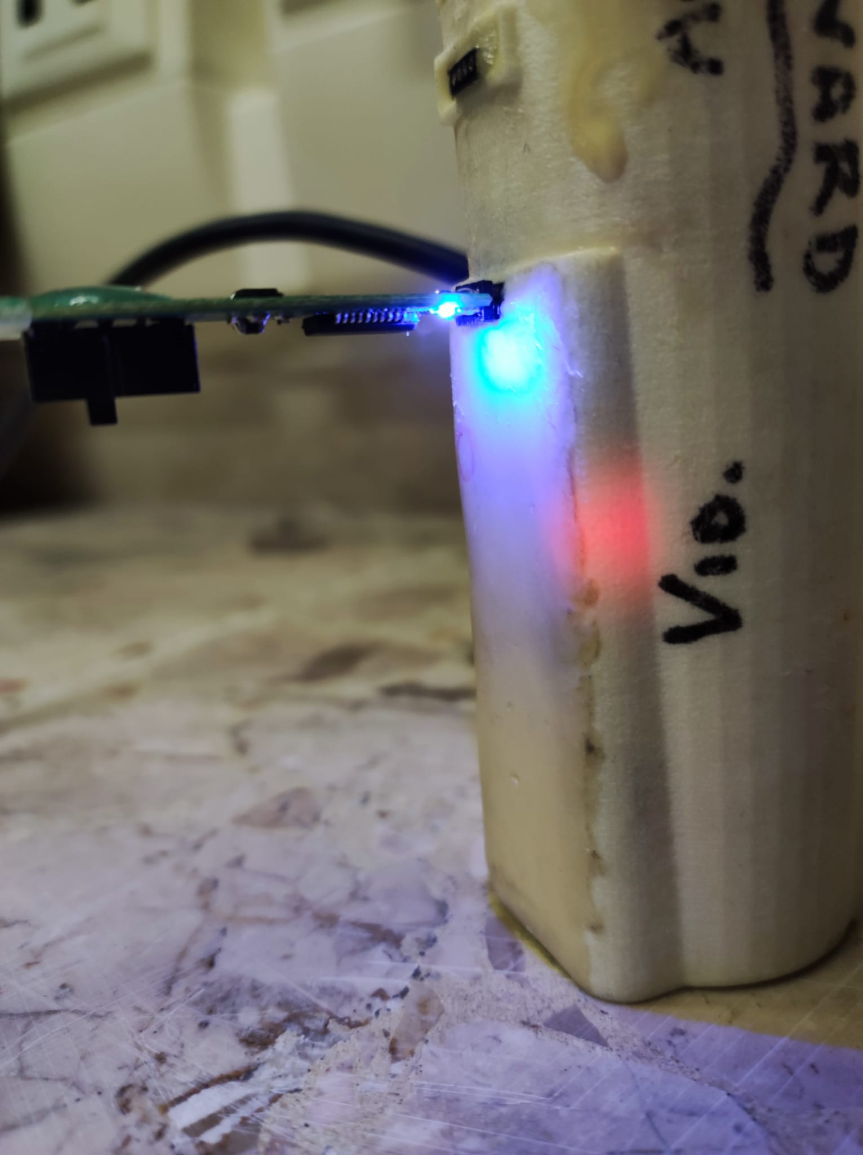

**LED LIGHTS FACING TOWARD THE FRONT**

**LEDs can be seen transparently in the casing and are therefore very little evident (especially those of the AGMD), so it is necessary to work in the dark or at least with little light.**

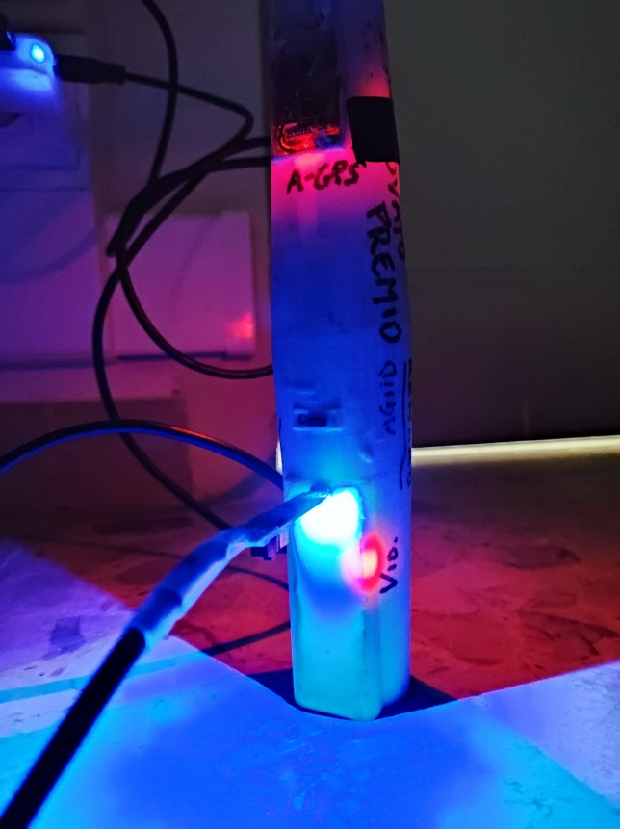

**AGMD logger**

Power on

- passage of the magnet near the connector (point indicated with a black oblique bar): the white LED starts flashing, first quickly and then about 1 time/sec, for 20 sec., ending with a double blink. In this phase it can be connected with AxyMan (see below).

Shutdown

- keep the magnet still on the point indicated with the black bar, the continuous LED lights up for 1 sec, immediately after the LED goes off quickly move the magnet away. You get a continuous lighting for about 1 sec, then a fast blinking followed by the switching off of the led, which indicates that the instrument is off.

Everytime

If you pass the magnet near the connector:

- if it starts flashing 1 time/sec it means that it was off and is turning on

- if yes, the LED lights up continuously for about 1 sec, it means that it is on (it can be turned off with the procedure described above).

To program the instrument or download the data, it must be connected to the PC when switched off, inserting the connector so that the lights are facing the front of the tag. Then it turns on and during the flashing of 20 seconds it connects with AxyMan2. To check the state of charge, use AxyMan2 as well.

In the tag, the AGMD is placed vertically, with the connector facing up. So pay attention to the recorded Acc and Mag values; refer to the diagrams in the manual, using the connector as a reference.

**Technocam video camera**

The video camera frames a field slightly shifted to the right and which starts at least 50 cm from the camera placed on the vertical support. At smaller distances, the field of view is quite narrow (about +/- 10° from the camera itself).

Power on

Hover the magnet over the red circle (top left of the smooth rectangle with the camera connector at the top), a slow flash starts and then a red/green light comes on indicating battery status. To check if it is on swipe the magnet quickly: it flashes quickly once.

Shutdown

Hold the magnet for 2 sec and then remove it when it starts flashing. Rapid flashing begins, followed by a long pause (3-4 sec) and subsequent rapid flashing.

Video download and battery charge

With the camera off.

Communication takes place via the cable with the small black button, inserting the connector so that the button faces the front (where the chamber opening is). The LED inside the chamber must light up, red or green depending on the charge).

In one position of the button, the blue light turns on and there is communication with the SD card (this can be seen from the explorer, from which the video files can be copied and then deleted) and the instrument is charged (the light inside the video camera is red or green at depending on the charge; it probably only stays green at the optimal voltage of 4.2 V). The battery should work for at least 15 hours but the video recording goes on for about 8/10 hours being limited by the capacity of the SD card (about 30 GB). When you remove the cable, the camera turns off.

Configuration

With camera on.

In the other position of the button, the green light turns on and allows the instrument to be configured using the GypsyCam software. To connect instrument and software, turn on the camera and while it is still flashing (it is turning on) click “connect”. The configuration consists in setting (i) a recording start delay, (ii) recordings of duration X at time intervals Y, (iii) date/time. [It is advisable to set the date/time just before deployment, otherwise the information is canceled during the blue light activation phases (as also written in the manual)]. [PC: It seems to me that it does NOT lose the date when it connects to blue light to download. So the configuration for me is useless]. When you remove the cable, the camera turns off.

**GPS-Argos**

Loading

to charge the GPS-Argos, connect the cable to the VHF socket so that the red and green lights point towards the front of the buoy. A red light on the GPS-Argos side lights up inside the buoy. The light turns green when fully charged.

Power on

- passage of the magnet in the center of Argos (black dot): the LED starts flashing (in the upper central part of Argos), first quickly and then about 1 time/sec, about 10-15 times. In this period the DIVID-PC connection must be made using the appropriate software (first connect it to the PC with cable from the Argos side with the cable LED towards the front of the buoy, then switch on Argos). If you pass the magnet across the center when it is on, you get a blink (if you hold it there, you get the steady light described below).

Shutdown

- hold the magnet in the center of Argos, the LED blinks, then lights up steadily. When it starts with steady light put the magnet on and off 2-3 times quickly. If it goes off, it makes several blinks, including a final series of quick blinks. If it doesn't make these quick blinks, the meter has NOT shut down.

Before the first use, it is necessary to communicate the Argos ID to the tag through the USB cable and the GypsySAT_User_Software program. The connection takes place by pressing Connect from the software as usual during the slow flashing phase after switching on (it is therefore advisable to physically connect the cable with the PTT off and switch it on afterwards). The ID provided by Argos in hexadecimal format must be inserted in the form and specify the start and end date of the tag's operation (it is important to make sure that the end date is much later than the deployment date). The SN field, on the other hand, cannot be modified. Once this info has been specified, press SEND: since there is no confirmation of the sending (nothing else happens), to check that it has been received, you must disconnect from the tag and then reconnect to see if the correct ID is shown.

This procedure must be carried out only once and the PTT connector is not used for anything else, except to check the charge of its battery, which can also be evaluated by the software above (but this charge can also be detected by the LED on the VHF which can be red or green).

**VHF**

Turns on/off by removing/replacing the small magnet on the equally sized circle.

Radio Frequency:

150,100

**GENERAL INFO:**

The tag should transmit for at least 10-15 days if surfacing; in the water it realizes that there is no GPS available and therefore saves energy.

The ARGOS-VHF battery operates between 4.2V (fully charged) – 3.7V. At 3.7V Argos shuts down, while the VHF continues to operate down to 3.0V (at this level it can be considered fully discharged). The recharging of the DIVID Argos-VHF batteries can have different speeds (ARGOS of the 3rd slowest, it takes up to 20 hours for a complete charge from 3.0V to 4.2V).

Argos codes: 225495 hex 33CE379